**Project Report**

**Of**

**DOOR TO DOOR**

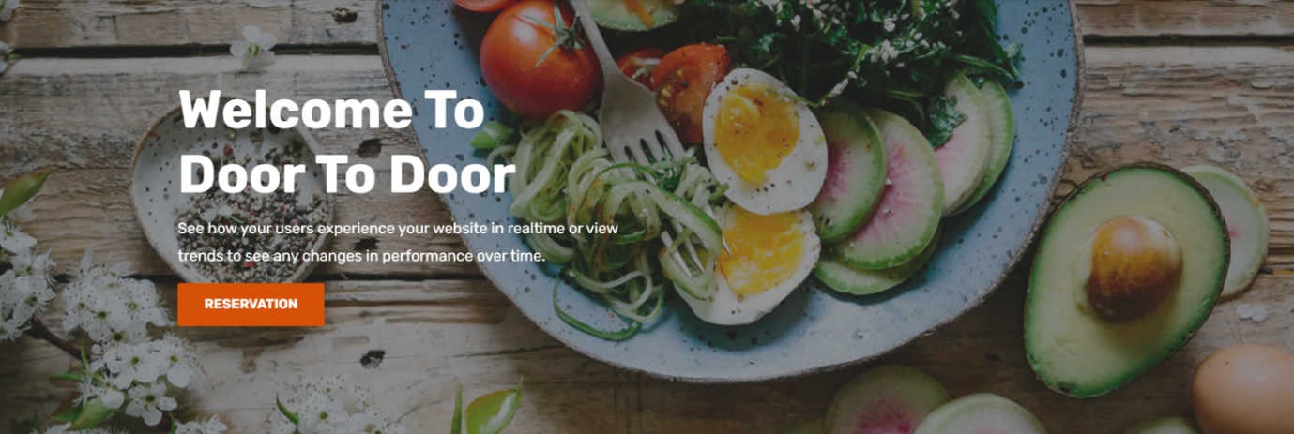

As partial fulfillment of

**Bachelor of Computer Application [T. Y. B. C. A.]**

Submitted to

**MATRUSHRI VIRBAI MAHILA COLLEGE OF COMMERCE, MGMT & IT**

Affiliated to

**SAURASHTRA UNIVERSITY, RAJKOT**

Project Guide : Mrs. HITAL DHAMSANIA

Submitted By : SHAILEE RACHCHH (20BCA084)

KHUSHALI MESVANIYA (20BCA070)

KHUSHI MEHTA (20BCA069)

BANSI RAIYANI (20BCA085)

**Index**

| **Sr. No.** | **Title** | **Page No.** |
| --- | --- | --- |
| 1 | **Justification of Title** | 1 |
| 2 | **Acknowledgement** | 2 |
| 3 | **Preface** | 3 |
| 4 | **Project Profile** | 4 |
| 5 | **Technology Study** | 5 |
| 5.1 | **About Front End** | 5 |
| 5.2 | **About Back End** | 8 |
| 6 | **Timeline Chart** | 10 |
| 7 | **SDLC Stage Implementation** | 11 |
| 7.1 | **Preliminary Investigation** | 11 |
| 7.2 | **System Analysis** | 13 |
| 7.3 | **System Design** | 14 |
|  | 1. **Data Dictionary** 2. **DFD(Data Flow Diagram)** 3. **ER Diagram** 4. **Normalization** | 14  17  23  25 |
| 8 | **Admin Site** | 27 |
| 9 | **Client Site** | 32 |
| 10 | **System testing** | 35 |
| 11 | **Pros & Cons of Project** | 41 |
| 12 | **Future Enhancement** | 42 |
| 13 | **Reference & Bibliography** | 42 |

**Justification of Title**

**DOOR TO DOOR**

* Having health veg tiffin service is the ultimate way to keep your body healthy and fit. What you eat affects your mental health also.
* The Door To Door (also called Tiffin service) constitutes a lunchbox delivery and return system that delivers hot lunches from homes to people at work in GUJARAT, especially in RAJKOT.
* The Door To Door are picked up in the late morning, delivered predominantly using bicycles and motorbikes and returned empty in the afternoon.
* Our lunchbox is actually the stainless-steel tiffin boxes, about 15 cm in diameter and 30 cm high that people carry from their home to office.

# Preface

# We would like to say that the project is a very essential part of the education quota. We are pleased to present this project report on B.C.A. Semester at MATUSHRI VIRBAIMA MAHILA COLLEGE OF COMMERCE, MANAGEMENT AND I.T.

* Project report is an interesting experience as we say it is difficult from particular aspects we come to know about the theoretical ideas of the matter.
* Your feedback is very important to improve our project knowledge.
* Once you login to our website you can see and order the meal from the menu of **DOOR TO DOOR**. We say it is difficult from a particular aspect. We come to know about the theoretical ideas of matter. By preparing this project we have understood The Need of practical training in the education field. It is easier to work with a computerized system.

**Acknowledgement**

* The success of any project is certainly not bound to the specific acknowledgement of the project.

* It is the collaborative effort of the people around an individual that enchant Success. The satisfaction that accompanies the successful completion of any talk would be unskillful co-operation made possible, whose constant direction and encouragement culminated all efforts with a favorable outcome.
* It is an event of great delight for us to get the opportunity of expressing our profound appreciation to **SAURASHTRA UNIVERSITY.**
* Personally we would like to convey our keen gratitude to the soul who directly or indirectly supported us in our project progress. We show our great wisdom of appreciation to our respectable **MRS. HITAL DHAMSANIA.**
* Who has mentored us in developing the project. We are grateful to her.
* Our guide who supported us throughout the growth of our work, who is always prepared to lead us during the evolution of projects.

# Project Profile

* Project Title **: “Door To Door”**
* Hardware Used : 250GB Hard Disk, 3GB RAM
* Operating System : Windows 10 Enterprise 32 bits
* Front End : ASP.NET with C#
* Back End : MySql Server
* Documentation Tool : Microsoft Word
* Central Guide : Mrs. Hital Dhamsania.
* Project Duration : 3 Months
* Presentation By : SHAILEE RACHCHH (20BCA084)

KHUSHALI MESVANIYA (20BCA70)

KHUSHI MEHTA (20BCA069)

BANSI RAIYANI (20BCA085)

* Submitted To : Saurashtra University, Rajkot

# Technology Study

**ABOUT FRONT END**

* ASP and ASP.NET are server side technologies. Both technologies enable computer code to be executed by an Internet server. When a browser requests an ASP or ASP.NET file, the ASP engine reads the file, executes any code in the file and returns the result to the browser.
* ASP.NET is a web application framework developed and marketed by Microsoft to allow programmers to build dynamic web sites. It allows you to use a full featured programming language such as C# or VB.NET to build web applications easily.
* ASP.NET is a free framework for building great websites and web applications using HTML, CSS and JAVASCRIPT. You can also create web APIs and use real-time technologies like web Sockets. ASP.NET Core is an alternative to ASP.NET.
* ASP.NET is a web framework designed and developed by Microsoft. It is used to develop websites, web applications and web services. It is built on the Common Language Runtime (CLR) and allows programmers to write code using any supported .NET language.

**About Back End**

## MYSQL:

* **What is Database?**

A Database is a separate application that stores a collection of data. Each database has one or more distinct APIs for creating, accessing, managing, searching and replicating the data it holds.

* **What is RDBMS?**

We use the Relational Database Management System (RDBMS) to store and manage a huge volume of data. This is called relational because all the data is stored into different tables and relations are established using primary keys or other keys known as foreign keys.

* **MySql Database:**

MySql is a fast, easy-to-use RDBMS being used for many small and big businesses. Mysql is developed, marketed and supported by MySql AB, which is a Swedish company. MySql is becoming so popular for many reasons:

* It is released under an open-source license
* It handles a large subset of the functionality of the most expensive and powerful database packages.
* It uses a standard form of well known SQL data language.
* It is very friendly to PHP, the most appreciated language for web development.
* It supports a large database, up to 50 million rows or more.
* The default file size limit for a table is 4GB.
* It is customizable. The open-source GPL license allows programmers to modify the MySql software to fit their own specific environment.

**TIMELINE CHART**

| **Task No.** | **Task Name** | **Start Date** | **End Date** | **Duration** |
| --- | --- | --- | --- | --- |
| 1. | System Analysis | 14-11-2022 | 10-12-2022 | 28 Days |
| 2. | Analysis Study | 11-12-2022 | 31-12-2022 | 21 Days |
| 3. | Design | 01-01-2023 | 12-01-2023 | 12 Days |
| 4. | Coding | 13-01-2023 | 24-01-2023 | 12 Days |
| 5. | Testing | 25-01-2023 | 31-01-2023 | 7 Days |
| 6. | Implementation | 01-02-2023 | 07-02-2023 | 7 Days |
| 7. | Final Testing | 08-02-2023 | 11-02-2023 | 3 Days |
|  | | | | **90 DAYS** |

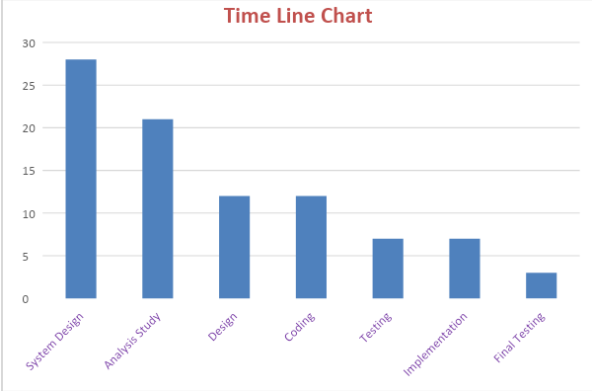

# SDLC STAGE WISE

# IMPLEMENTATION

# System Analysis:

## Description of Manual System:

* There were no websites available for visitor management related to this digital world.
* The main drawback of the Visitor Management System includes the time consuming process.

1. **Description of Proposed System :**

* In today’s complex world with the help of the internet, a person can easily do anything anytime and anywhere.
* This is the biggest advantage of developing this kind of website for them as well as for companies who can afford to develop this system.
* **System Design:**
  1. **Data Dictionary:-**
* A Data Dictionary is a set of information describing the contents, format and structure of a database and the relationship between its elements, used to control access to and manipulate of the database.
* It describes the meanings and purposes of data elements within the Context of a project, and provides guidance on interpretation,Accepted meanings and representation.
* A Data Dictionary also provides metadata about data elements.

**1. ADMIN**

| **Column Name** | **Data Type** | **Size** |
| --- | --- | --- |
| a_id (primary key) | Int | 50 |
| a_nm | Varchar | 100 |
| a_password | Varchar | 100 |

**2. CATEGORY**

| **Column Name** | **Data Type** | **Size** |
| --- | --- | --- |
| cat_id (primary key) | Int | 50 |
| cat_nm | Varchar | 20 |
| cat_img | Varchar | 100 |
| Description | Varchar | 100 |

**3. REGISTRATION:**

| **Column Name** | **Data Type** | **Size** |
| --- | --- | --- |
| r_id (primary key) | Int | 80 |
| Name | Varchar | 100 |
| Gender | Varchar | 20 |
| Address | Varchar | 300 |
| City | Varchar | 100 |
| State | Varchar | 50 |
| Pincode | Varchar | 50 |
| mo_no | Varchar | 50 |
| e_id | Varchar | 50 |
| Uname | Varchar | 50 |
| Pass | Varchar | 50 |

**4. CART:**

| **Column Name** | **Data Type** | **Size** |
| --- | --- | --- |
| cart**_**id (primary key) | Int | 50 |
| cat**_**id (foreign key) | Int | 70 |
| sub**_**id (foreign key) | Int | 50 |
| i**_**id | Int | 70 |
| i**_**name | Varchar | 500 |
| i**_**image | Varchar | 500 |
| i**_**price | Varchar | 500 |
| Qty | Int | 70 |
| Amount | Int | 80 |
| Uname | Varchar | 70 |

**5. SUB CATEGORY:**

| **Column Name** | **Data Type** | **Size** |
| --- | --- | --- |
| sub_id (primary key) | Int | 10 |
| cat_id (foreign key) | Int | 10 |
| sub_nm | Varchar | 100 |
| sub_img | Varchar | 30 |

**6. BILL**

| **Column Name** | **Data Type** | **Size** |
| --- | --- | --- |
| b_id (primary key) | Int | 50 |
| Uname | Varchar | 50 |
| i_id (foreign key) | Int | 70 |
| i_name (foreign key) | Varchar | 100 |
| i_price (foreign key) | Int | 50 |
| Qty | Int | 70 |
| Total | Int | 50 |
| Date | Varchar | 50 |

**7. ITEMS**

| **Column Name** | **Data Type** | **Size** |
| --- | --- | --- |
| i_id (primary key) | Int | 50 |
| cat_id (foreign key) | Int | 50 |
| sub_id (foreign key) | Int | 70 |
| i_name | Varchar | 30 |
| i_price | int | 50 |
| i_image | Varchar | 100 |
| Qty | Int | 50 |
| Total_qty | Int | 50 |
| i_description | Varchar | 500 |

**8. CHECKOUT:**

| **Field Name** | **Data Type** | **Size** |
| --- | --- | --- |
| c_id (primary key) | Int | 50 |
| Name | Varchar | 100 |
| Address | Varchar(500) | 500 |
| City | Varchar(100) | 100 |
| State | Varchar(200) | 200 |
| Pincode | Int | 50 |
| mo_no | Varchar(100) | 100 |
| E_id | Varchar(200) | 200 |

**9. FEEDBACK:**

| **Column Name** | **Data Type** | **Size** |
| --- | --- | --- |
| Id (primary key) | Int | 30 |
| Name | Varchar | 50 |
| Review | Varchar | 50 |

**10. CONTACT:**

| **Column Name** | **Data Type** | **Size** |
| --- | --- | --- |
| Name | Varchar | 500 |
| Email | Varchar | 200 |
| Message | Varchar | 100 |

**B. Data Flow Diagram (DFD)**

* DFD is the abbreviation for Data Flow Diagram.
* The flow of data of a system or a process is represented by DFD.
* It also gives insight into the inputs and outputs of each entity and the process itself.
* DFD does not have control flow and no loops or decision rules are present.
* It can be used for the visualization of data processing.
* It does not show information about process timing or whether processes will operate in sequence or in parallel, unlike a traditional structured flowchart which focuses on control flow or UML activity workflow diagrams, which presents both control and data flows as a unified model.

# Symbols used in DFD

|  | **Arrows** | The Flow of data  Between data stores, external entities and processes. |
| --- | --- | --- |
|  | **Circles** | A Process manipulates data. |
|  | **Open – Ended Boxes** | Data stores or places where data is held temporarily or permanently. |
|  | **Square** | External entities such as people or other systems that feed data to or take data from the system. If the external entity is a system, remove the person from the box. |

**Rules of Data Flow Diagram (DFD)**

* The name of the entity should be easy and understandable without any extra assistance **(like comments).**
* The processes should be numbered or put in an ordered list to be referred to easily.
* The DFD should maintain consistency across all the DFD levels.
* A single DFD can have maximum processes up to 9 and minimum 3 processes.

**Advantages of Data Flow Diagram**

* It helps us to understand the functionality and the limits of a system.
* It is used as a part of the system documentation File.

**Disadvantages of Data Flow Diagram**

* At times DFD can confuse the programmers regarding the system.
* Data Flow Diagrams take a long time to be generated and many times due to these reasons analysts are denied permission to work on it.

## Steps to Create DFD

1. Create a List of Activities.
2. Construct Context Level DFD.
3. Constructs 0 Levels DFD.
4. Constructs 1 Level DFD.

**List of Activities in Our Project:-**

1. User/Admin Login
2. Add/View/Edit/Delete visitor’s data.
3. View User – Info Details.
4. View Department.

***DFD 0 LEVEL DIAGRAM :***

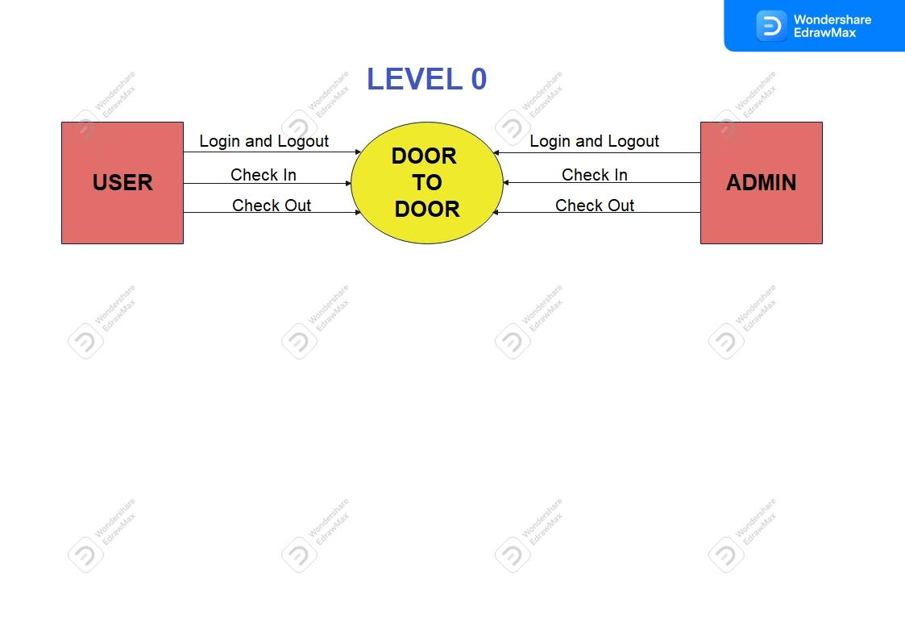

***DFD 1 LEVEL DIAGRAM :***

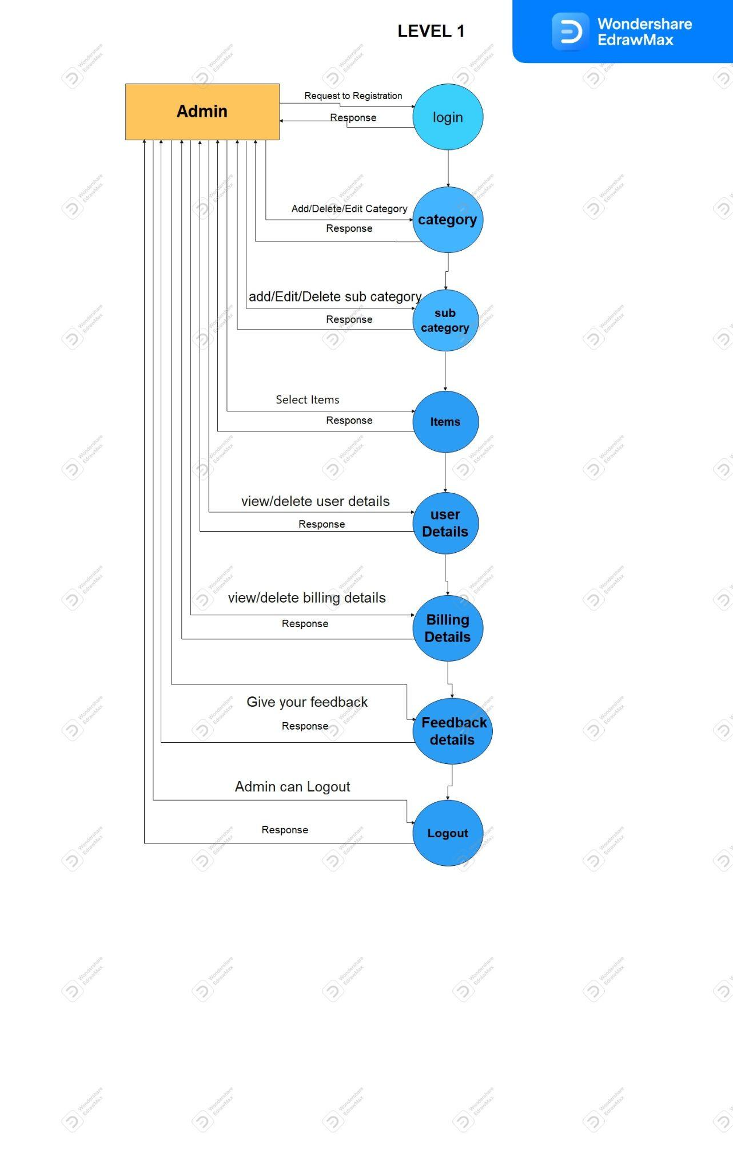

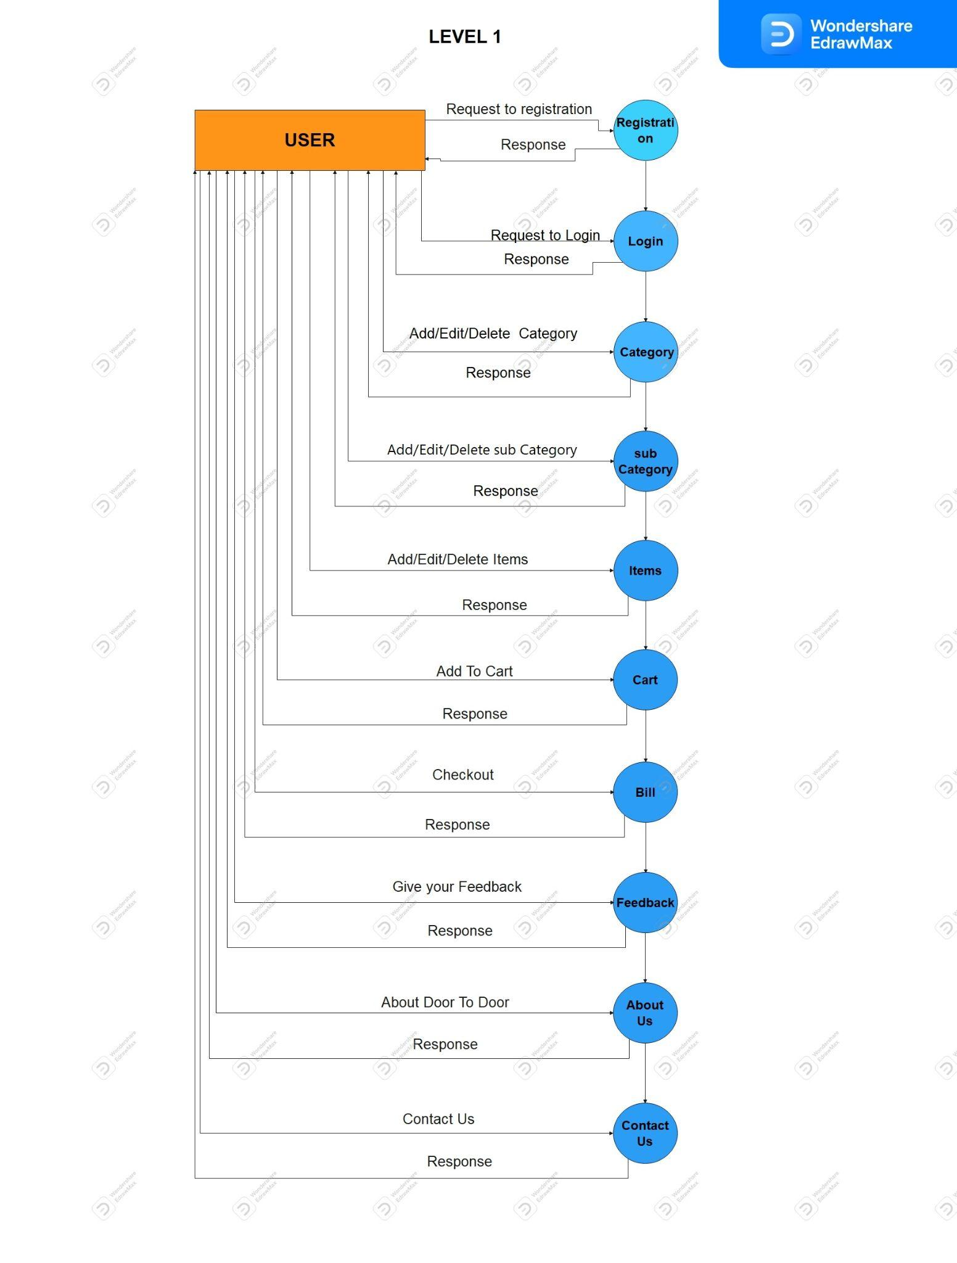

***DFD 2 LEVEL DIAGRAM :***

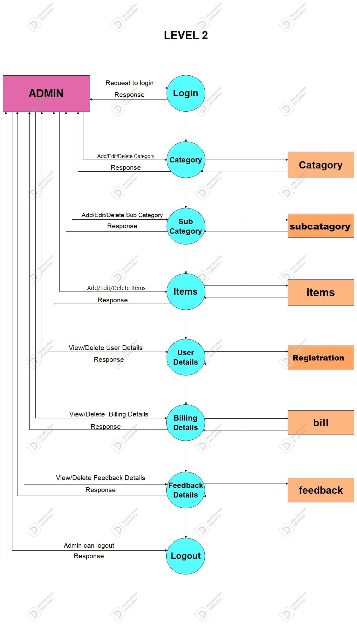

**LEVEL 2**

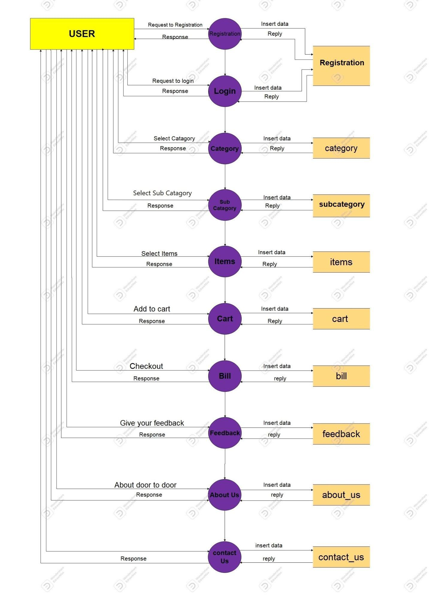

**C. ER Diagram:**

An Entity – Relationship Model(ER Model) describes the structure of a database with the help of a diagram, which is known as Entity relationship Diagram.

* + An ER Diagram shows the relationship among entity sets.
  + An ER Model is a Design or blueprint of a database that can later be implemented as a database.
  + Three main Components of ER Diagram are:-
    1. Entity
    2. Attribute
    3. Relationship

1. Entity:-

• An Entity is an object or component of data.

• An Entity is represented as a rectangle in an ER Diagram.

1. Attributes:-

• An Attribute describes the property of an entity.

• An attribute is represented as Oval in an ER Diagram.

1. Relationship:-

• A Relationship shows the relationship among entities.

• A Relationship is represented by a diamond shape.

**ER - DIAGRAM:**

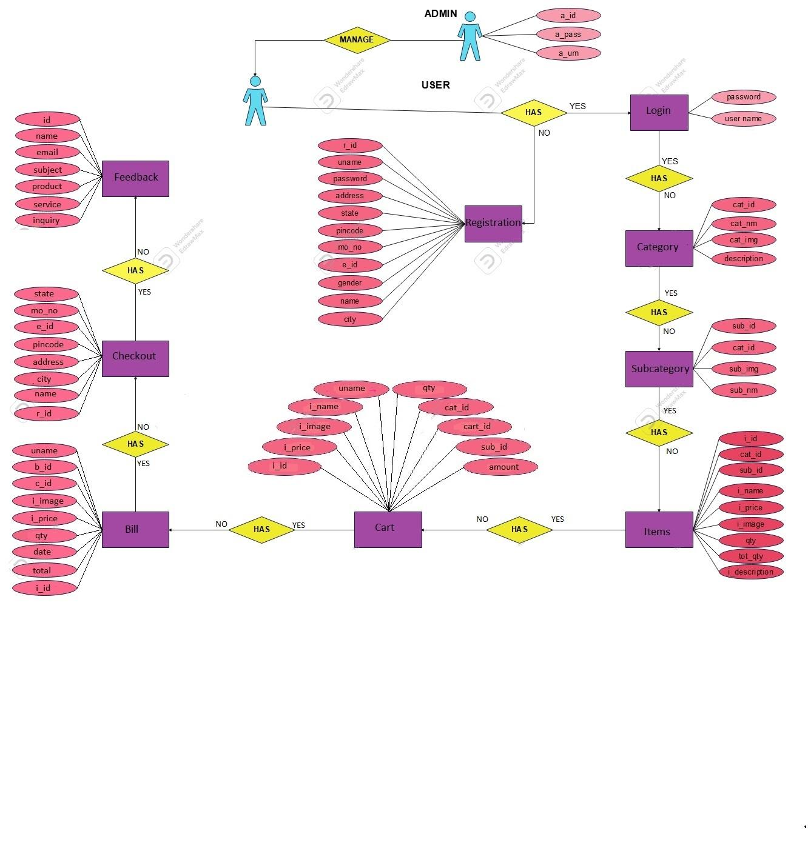

# D.Normalization:-

* Normalization is the process of organizing the data in a database.
* It is used to minimize the redundancy from a relation or set of relations.
* Normalization divides the larger table into smaller tables and links them using relationships.

## 1NF (Second Normal Form)

If a relation contains a composite or multi-valued attribute, it violates first normal form or a relation is in first normal form if it does not contain any composite or multi-valued attribute.

## 2NF (Second Normal Form)

* A relation is in 2NF if it has **No Partial Dependency,** i.e.**,** no non-prime attribute is dependent on any proper subset of any candidate key of the table.
* it is a normal form used in database normalization.
* Non -prime attribute of relation is an attribute that is not a part of any candidate key of the relation.

## *3NF (Third Normal Form)*:

* A relation is in third normal form, if there is **no transitive dependency** for.

Non-prime attributes as well as it is in second normal form.

* Third normal form is a normal form that is used in normalizing database design to reduce the due line of data and ensure referential integration by ensuring that.
* ALL ENTITY IS IN SECOND NORMAL.
* ALL THE ATTRIBUTES IN A TABLE ARE DETERMINED ONLY BY THE CANDIDATE KEYS OF THAT RELATIONAL AND NOT BY ANY NON-PRIME ATTRIBUTES.
* 3NF was designed to improve database processing while minimizing storage cast.
* 3NF data modeling was ideal for ***online transaction processing (OLTP)***. Application with heavy order enters the type of needs.



***BCNF (Boyce – Codd Normal Form):***

* It is an advanced version of 3NF that’s why it is also referred to as 3.5NF. BCNF is stricter than 3NF.
* Boyce-codd normal form (or BCNF or 3SNF) is a normal form used in database normalization.
* It is a slightly stranger version of the 3 Normal forms (3NF).
* BCNF was developed to address certain types of anomalies not default with by 3NF as originally defended.
* If a relational schema is in BCNF then all redundancy based on functional dependency has been removed. Although other types of redundancy may still exist.

***Admin Side***

HEADER PAGE:

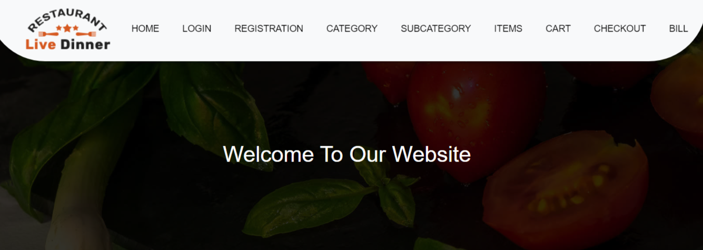

WELCOME PAGE:

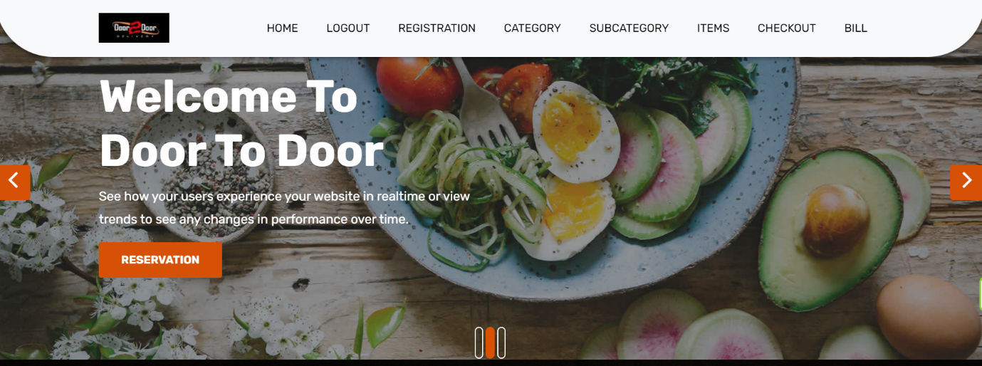

REGISTRATION PAGE:

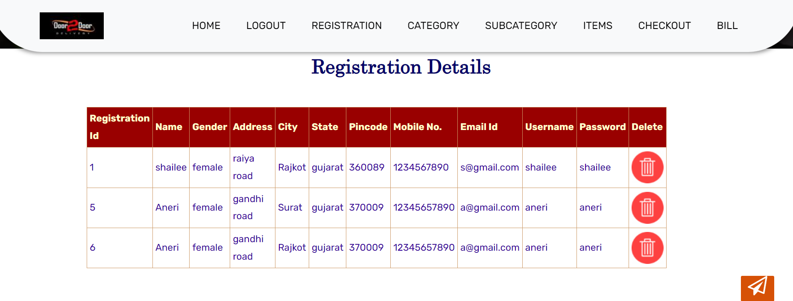

CATEGORY PAGE:

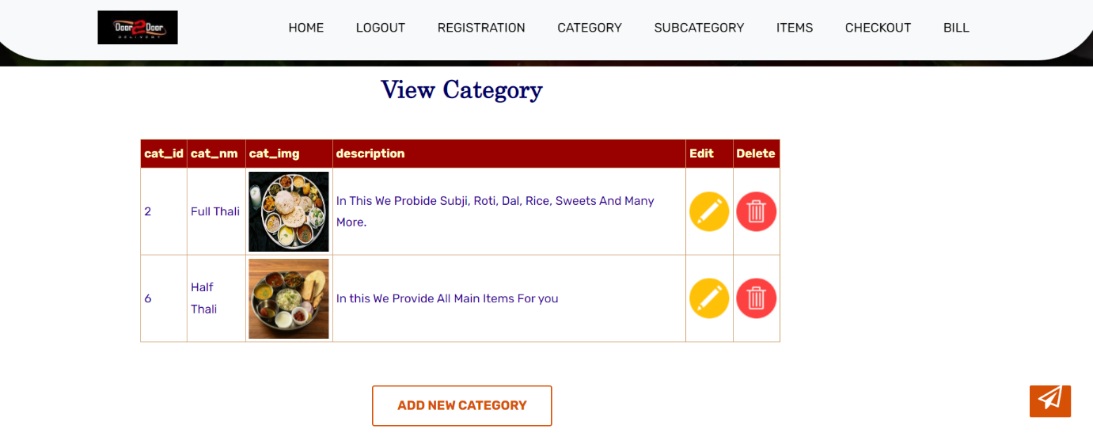

ADD NEW CATEGORY PAGE:

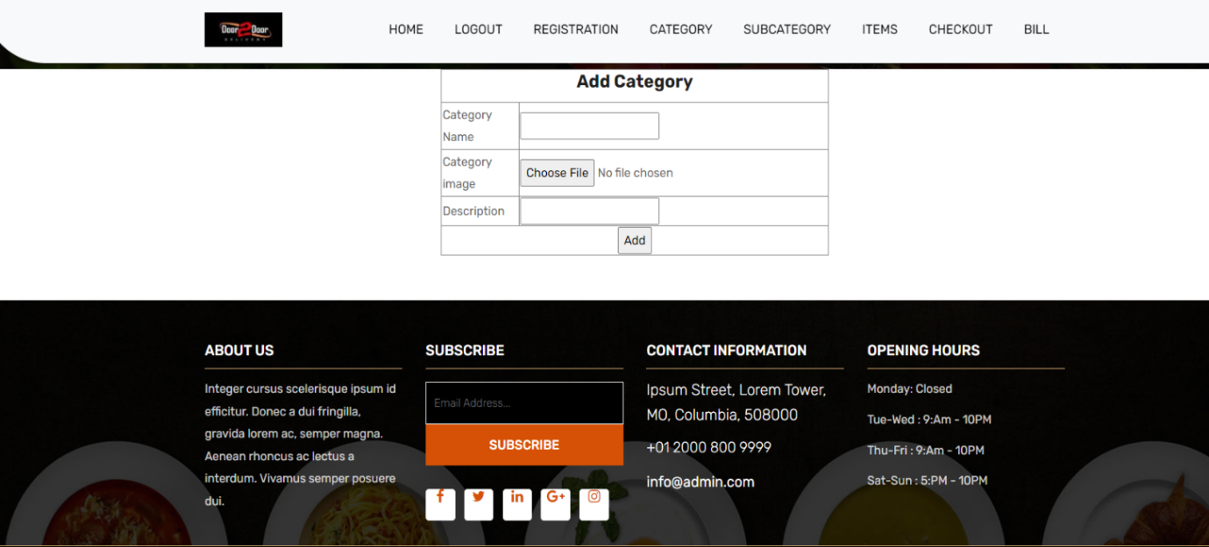

SUB CATEGORY PAGE:

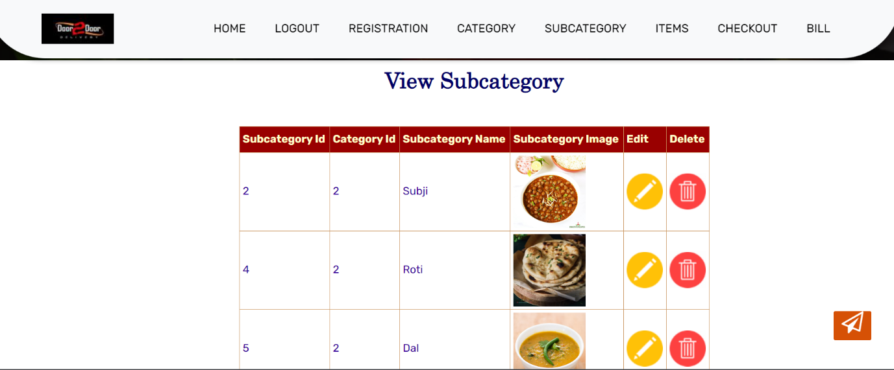

ADD NEW SUB CATEGORY PAGE:

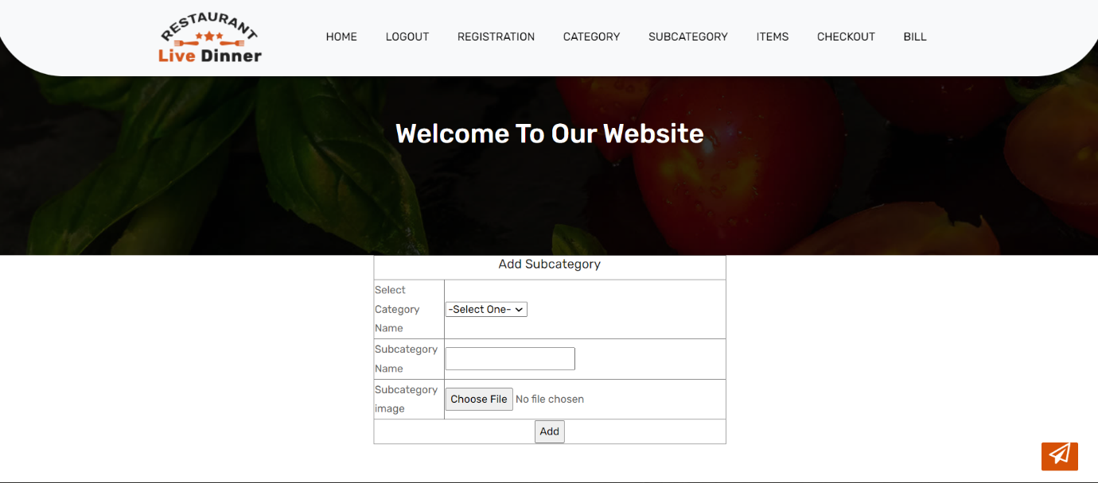

ITEMS PAGE:

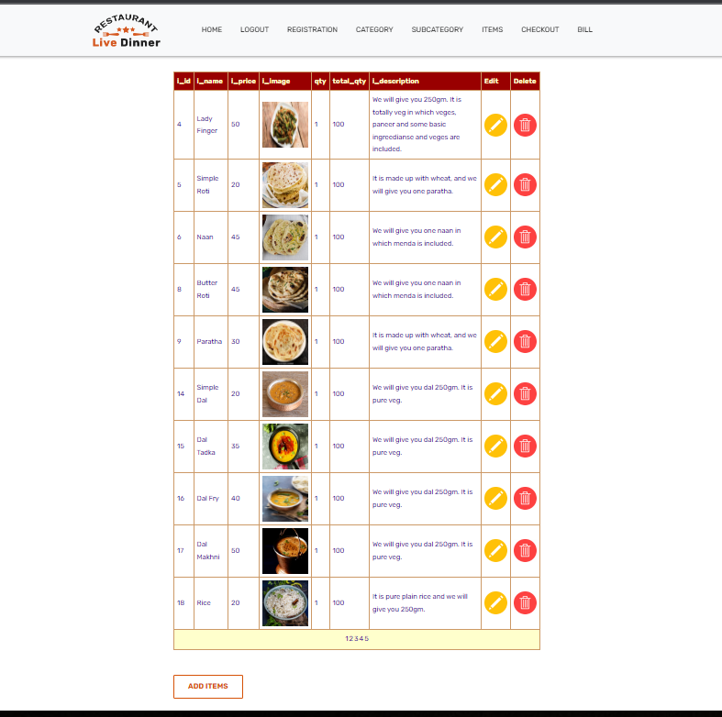

ADD NEW ITEMS PAGE:

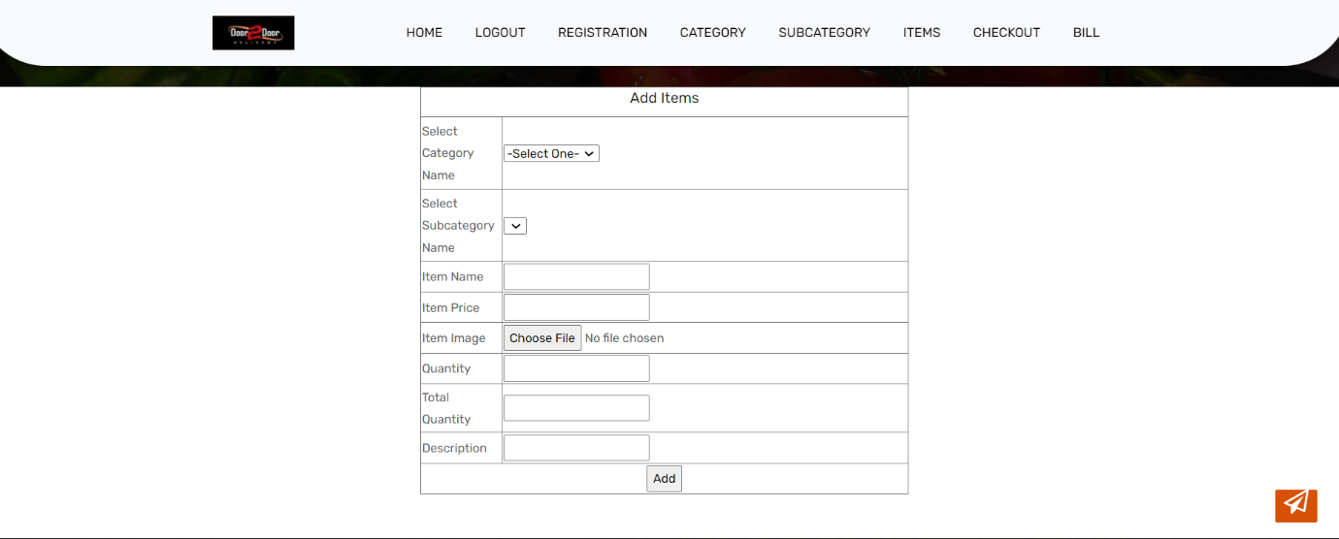

FEEDBACK PAGE:

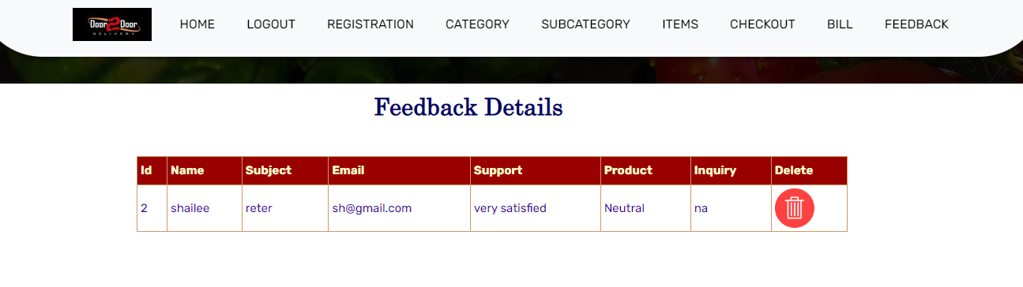

BILLING DETAILS PAGE:

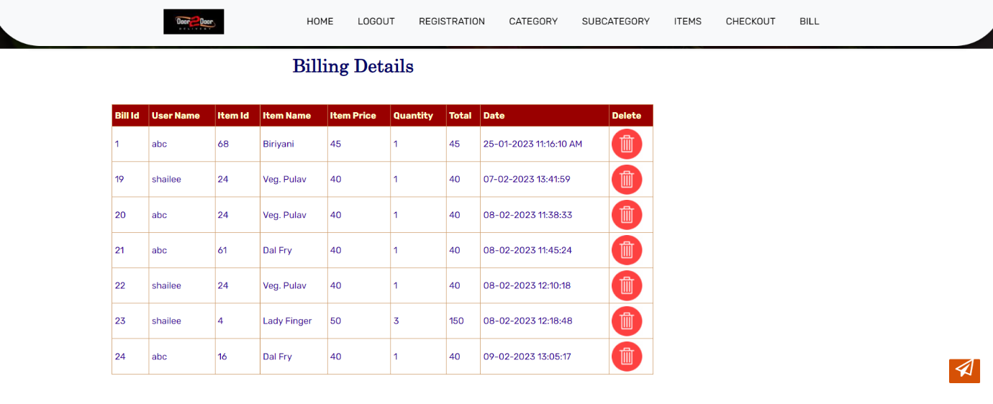

***Client Side***

HEADER PAGE:

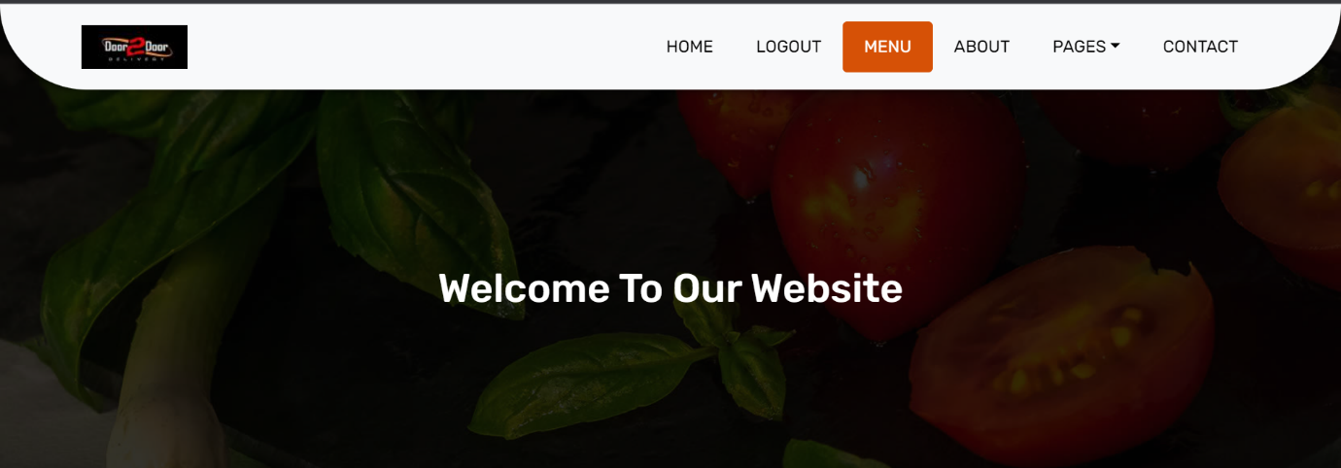

REGISTRATION PAGE:

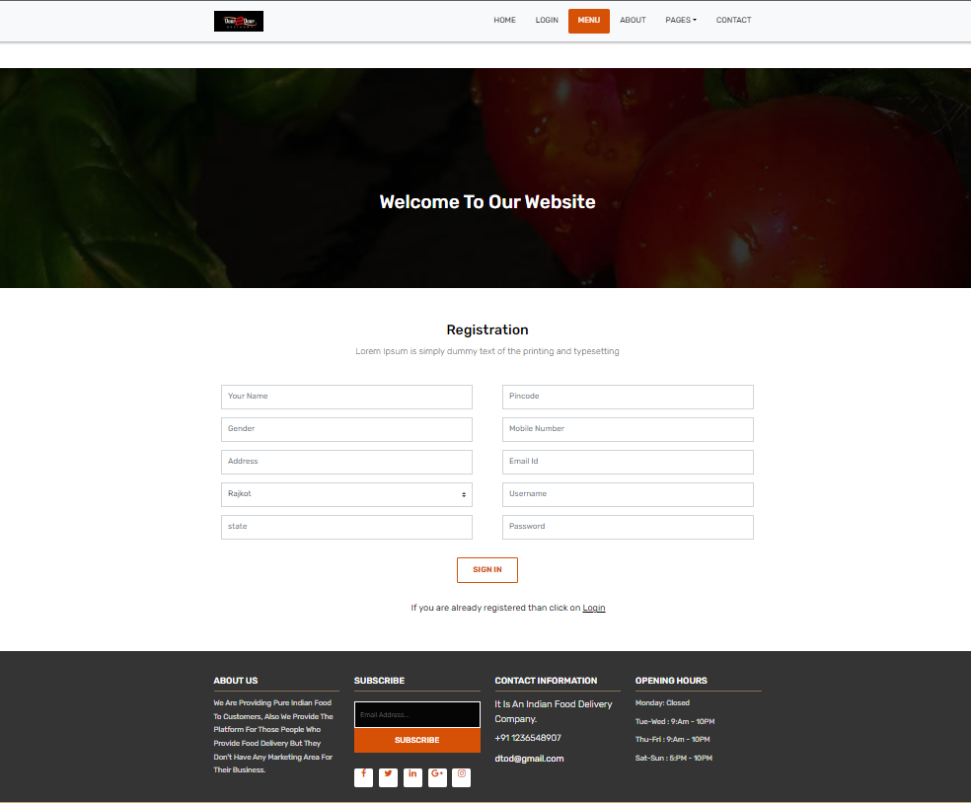

LOGIN PAGE:

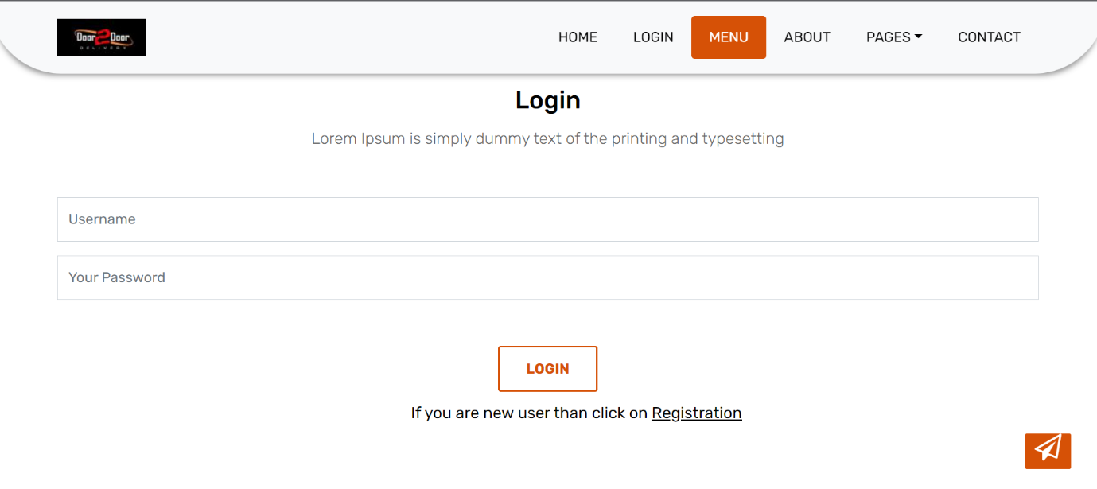

MENU PAGE:

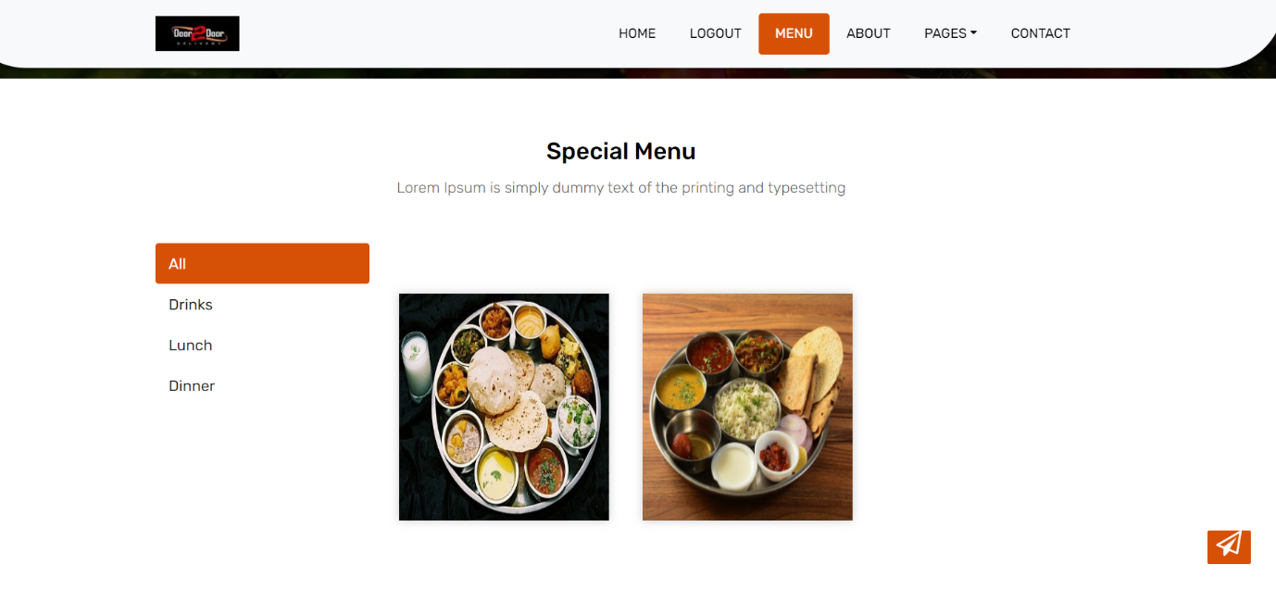

SUBCATEGORY OF FULL-THALI PAGE:

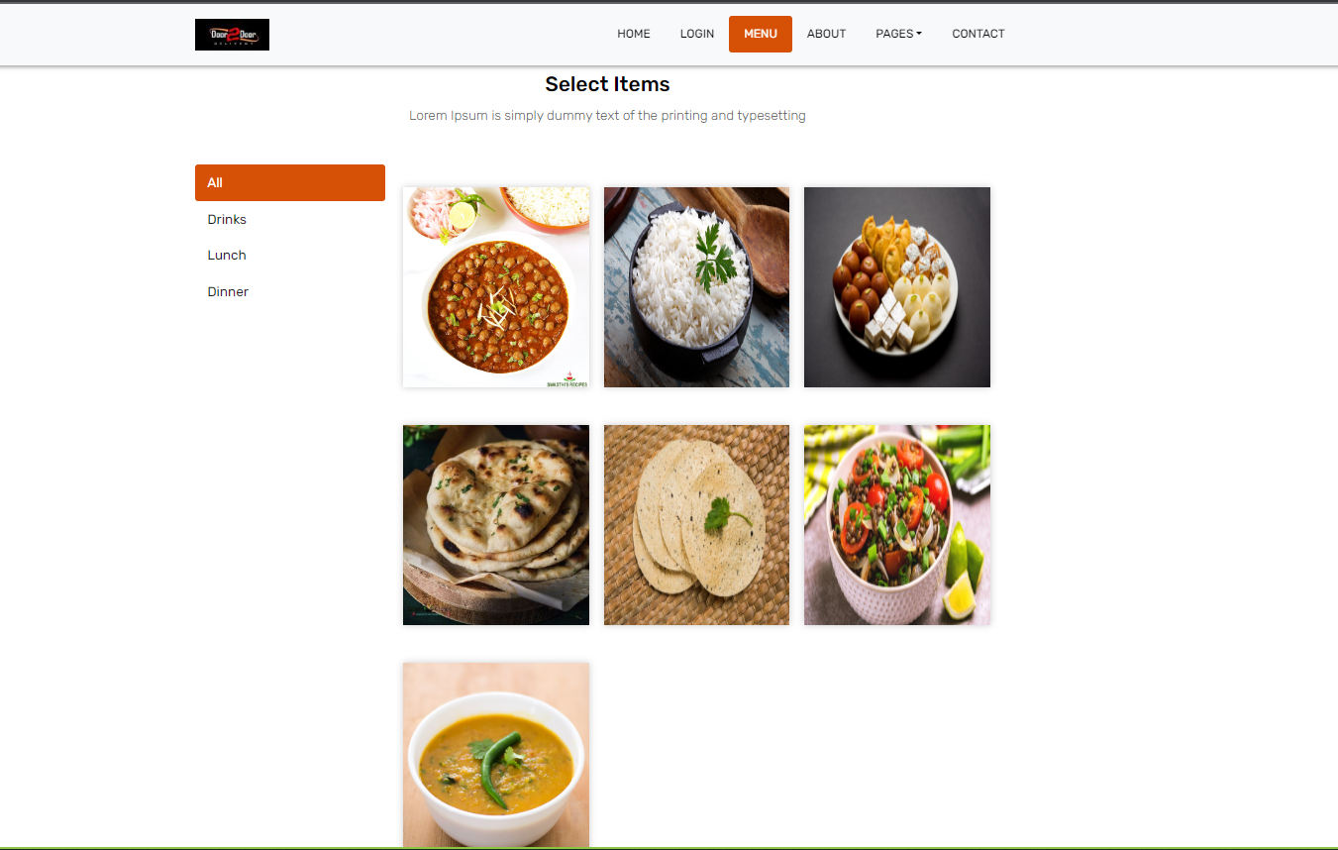

SUB CATEGORY OF HALF-THALI PAGE:

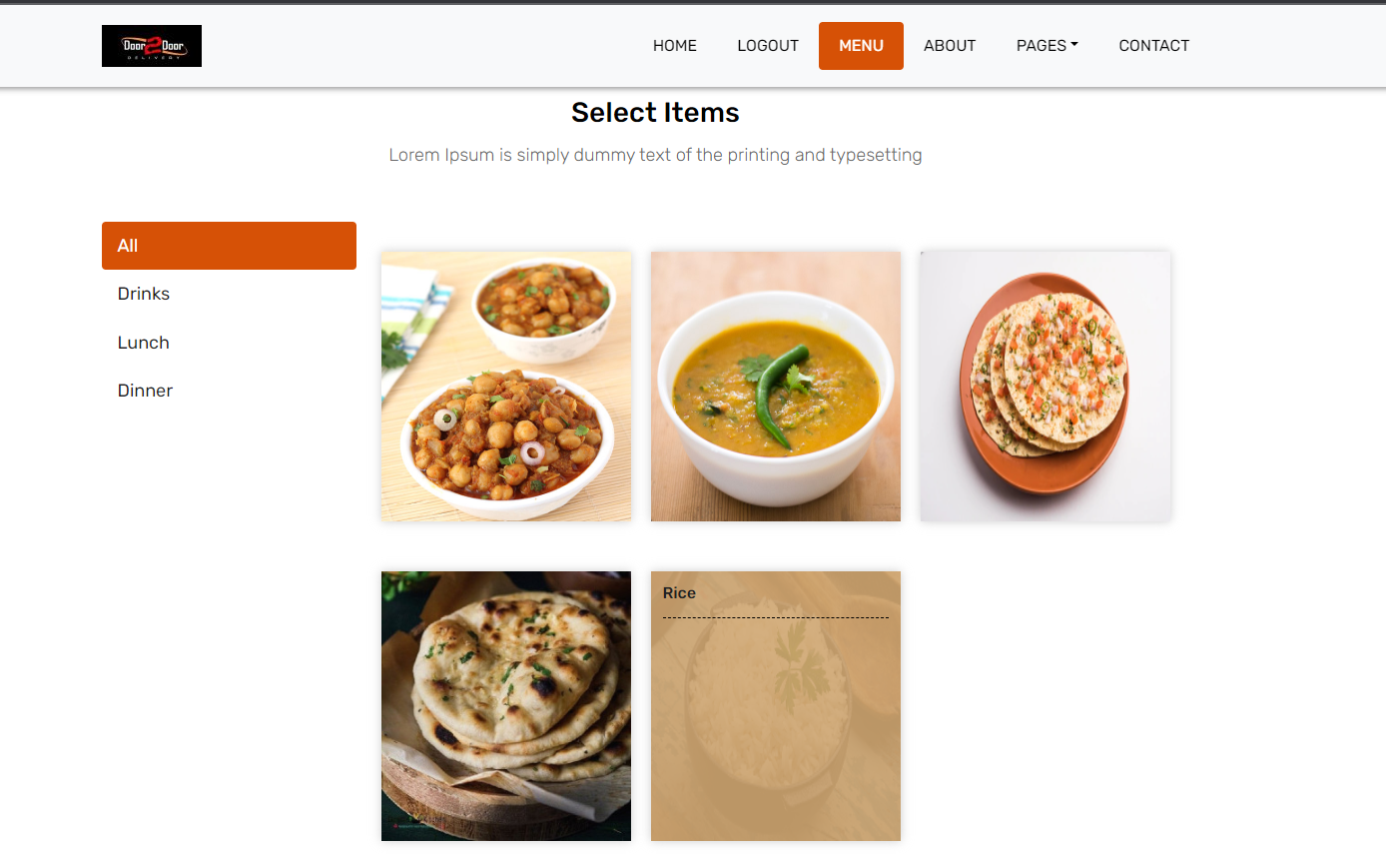

ITEMS OF FULL-THALI SABZI PAGE:

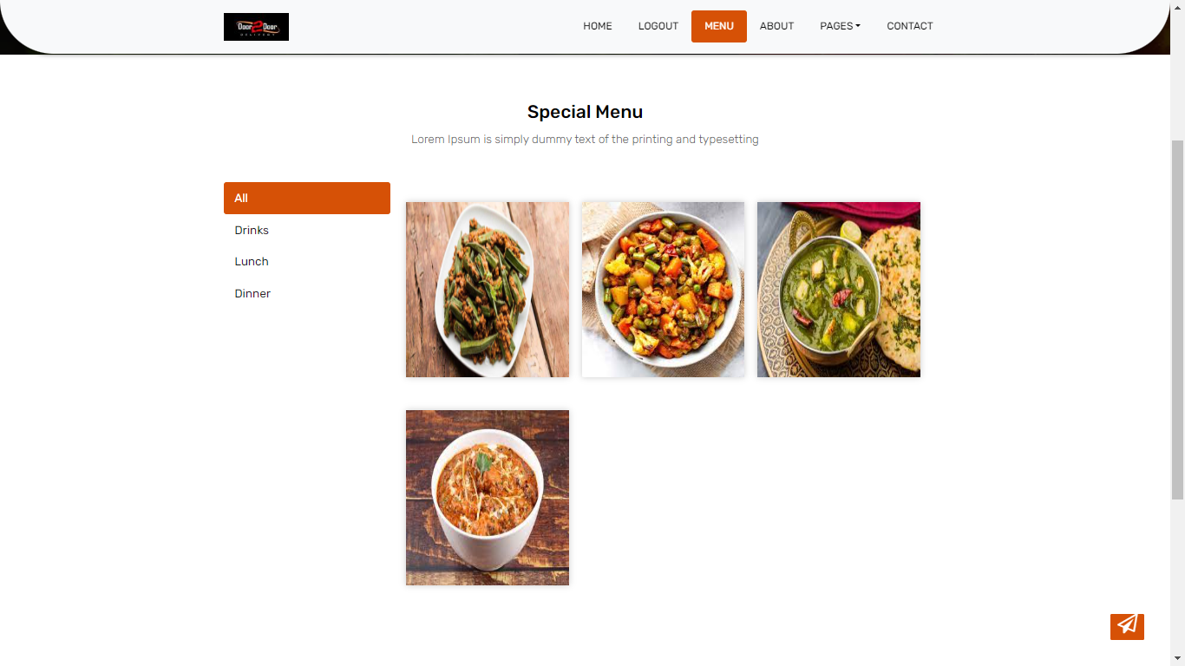

ITEMS OF FULL-THALI ROTI PAGE:

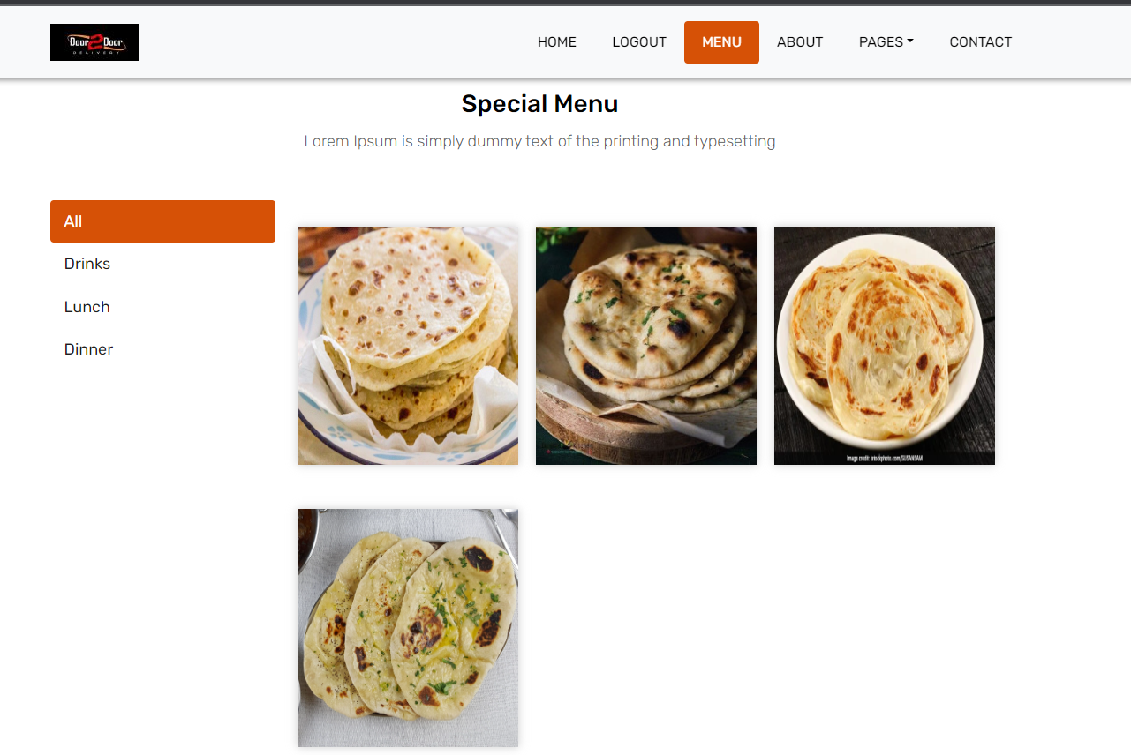

ITEMS OF FULL-THALI DAL PAGE:

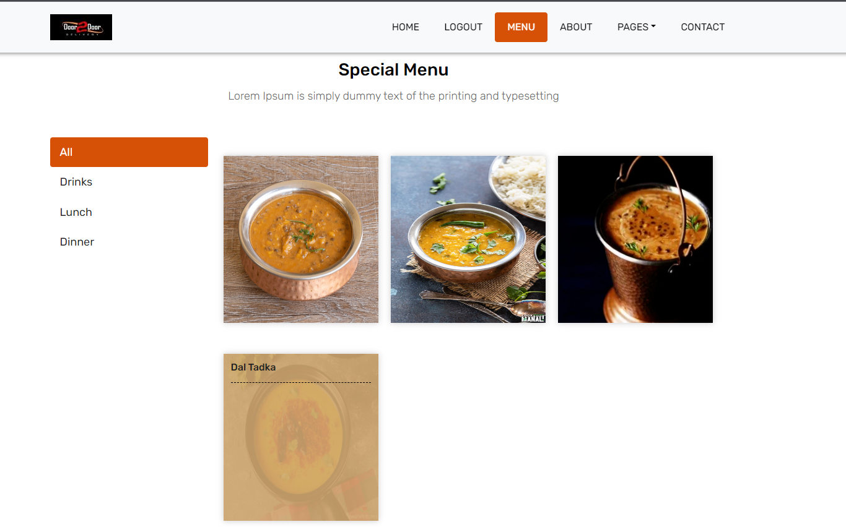

ITEMS OF FULL-THALI PAPAD PAGE:

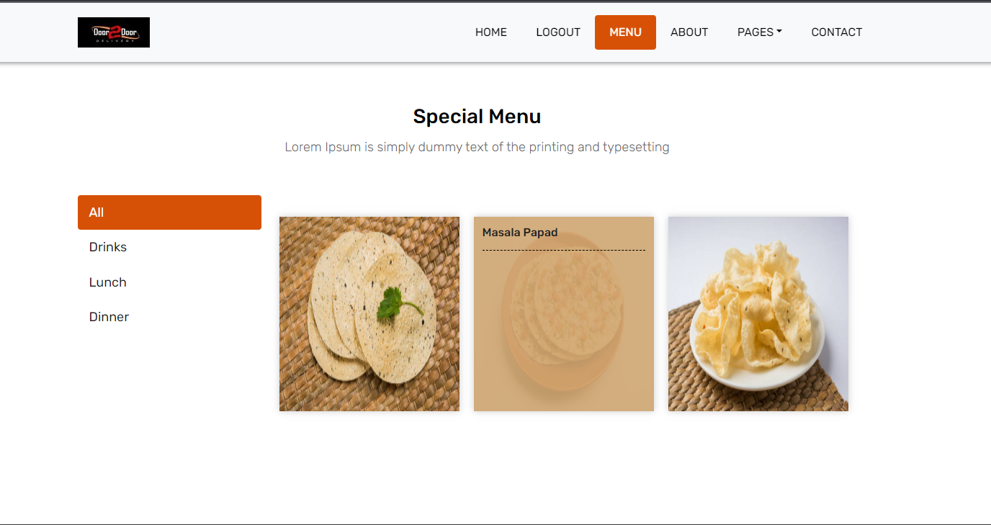

ITEMS OF FULL-THALI RICE PAGE:



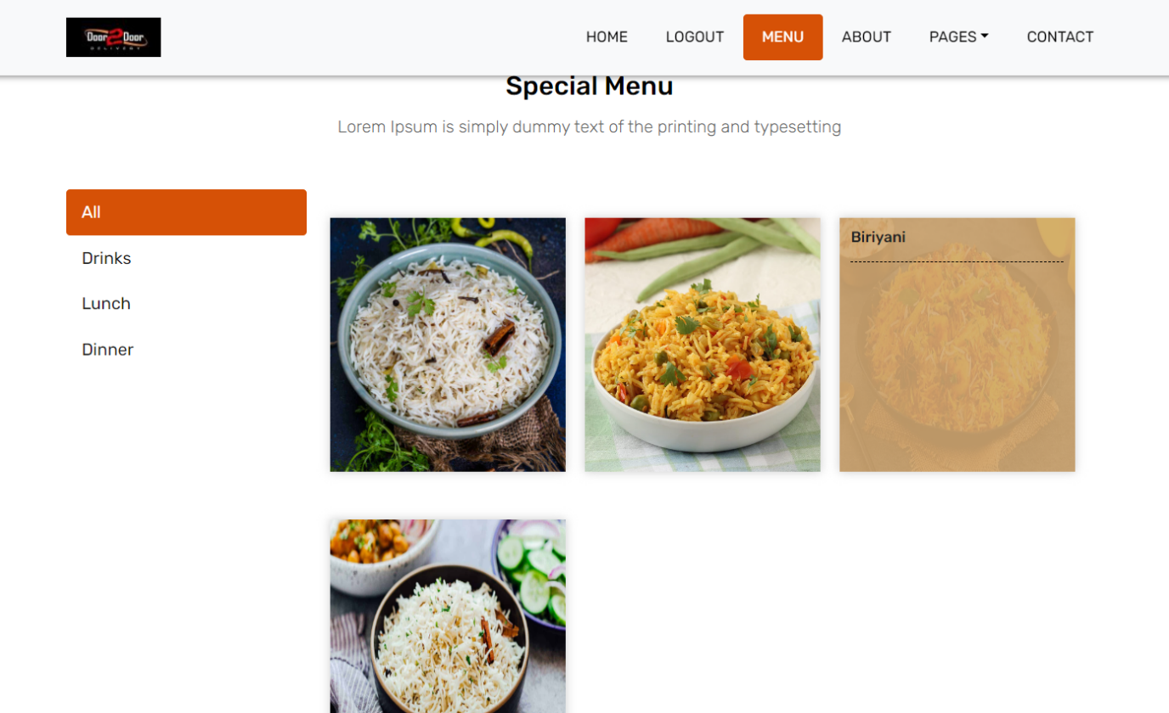

ITEMS OF FULL-THALI SALAD PAGE:

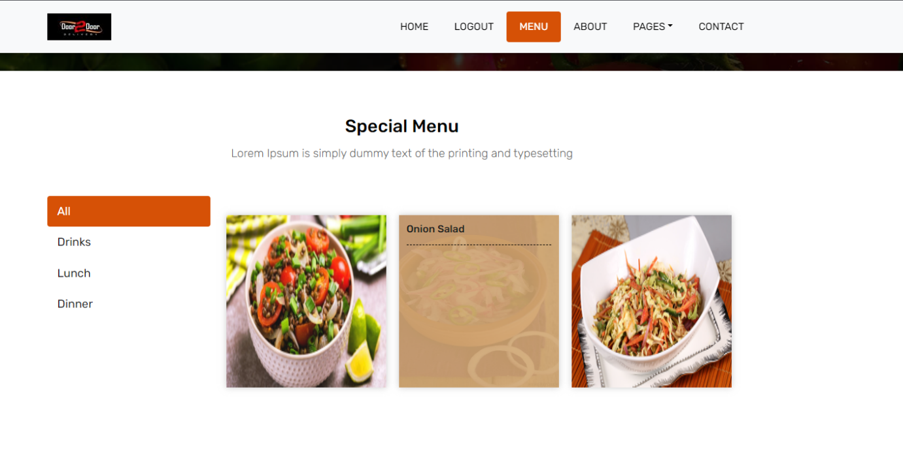ITEMS OF FULL-THALI SWEET PAGE:

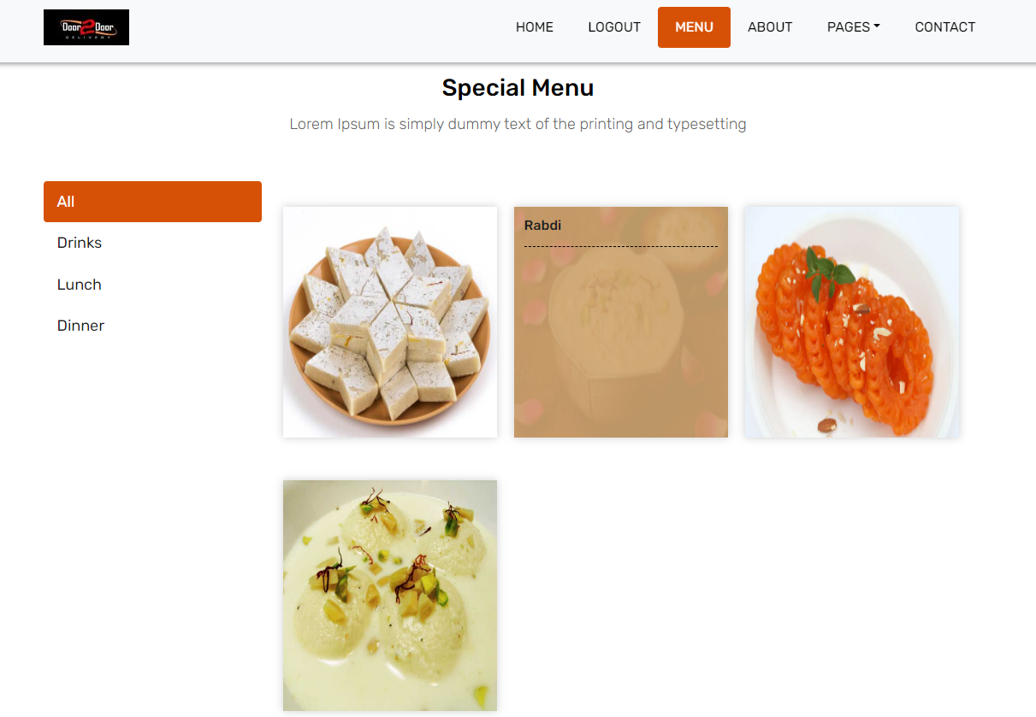

ITEMS OF HALF-THALI SABZI PAGE:

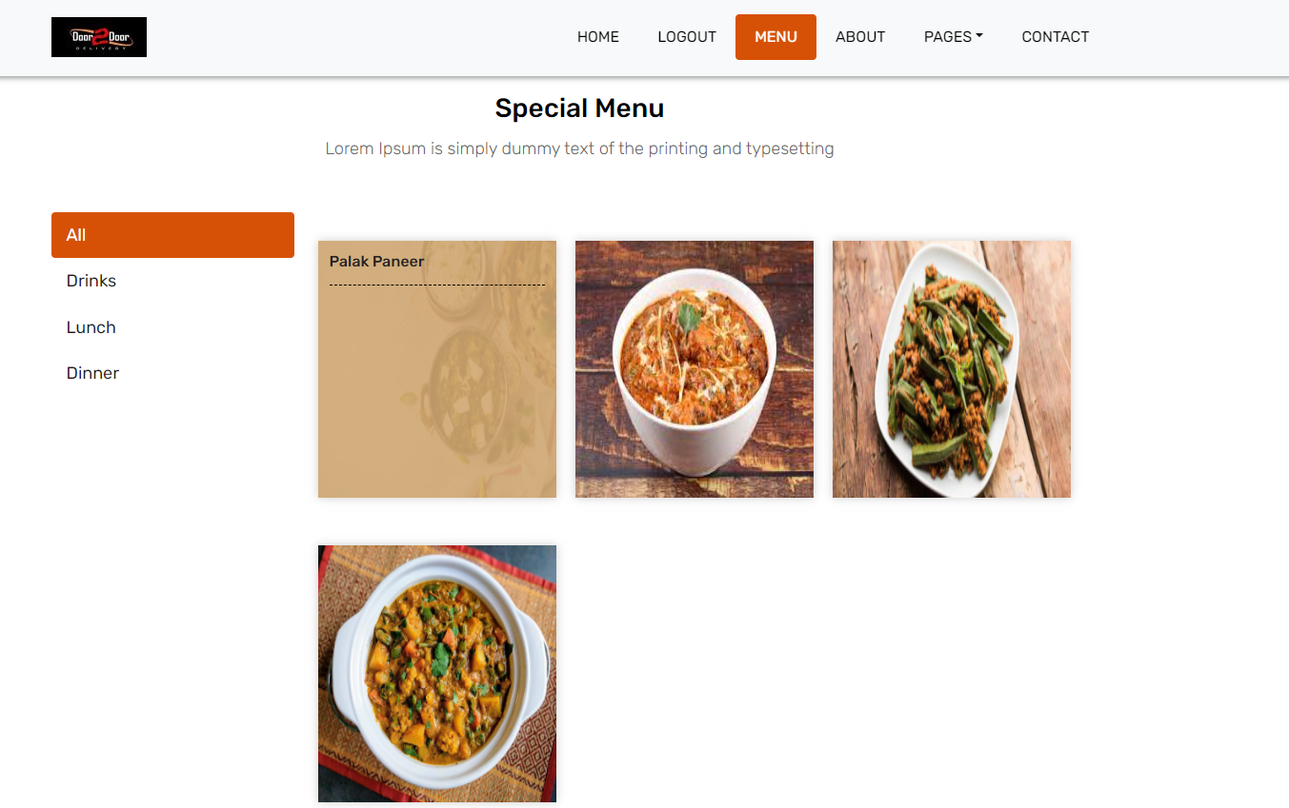

ITEMS OF HALF-THALI ROTI PAGE:

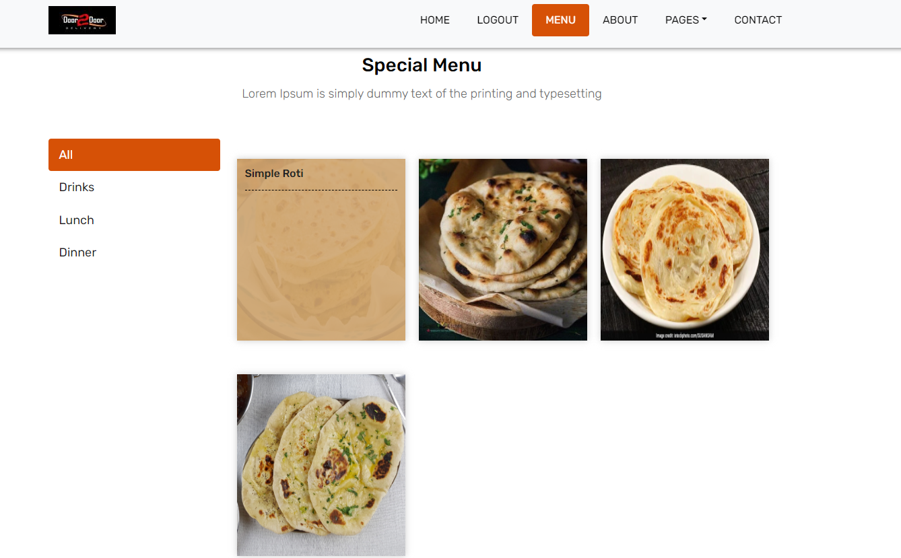

ITEMS OF HALF-THALI DAL PAGE:

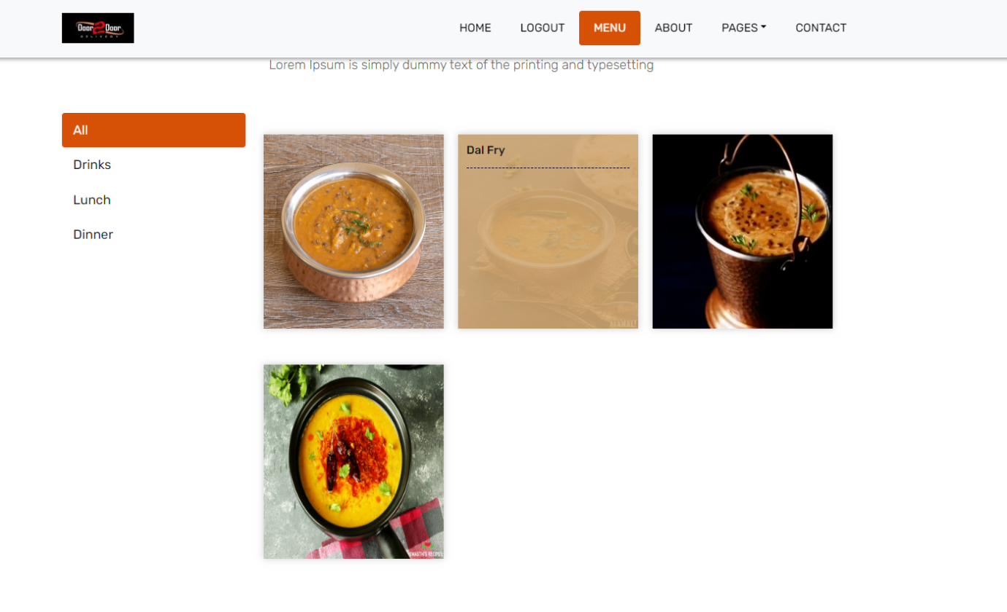

ITEMS OF HALF-THALI RICE PAGE:

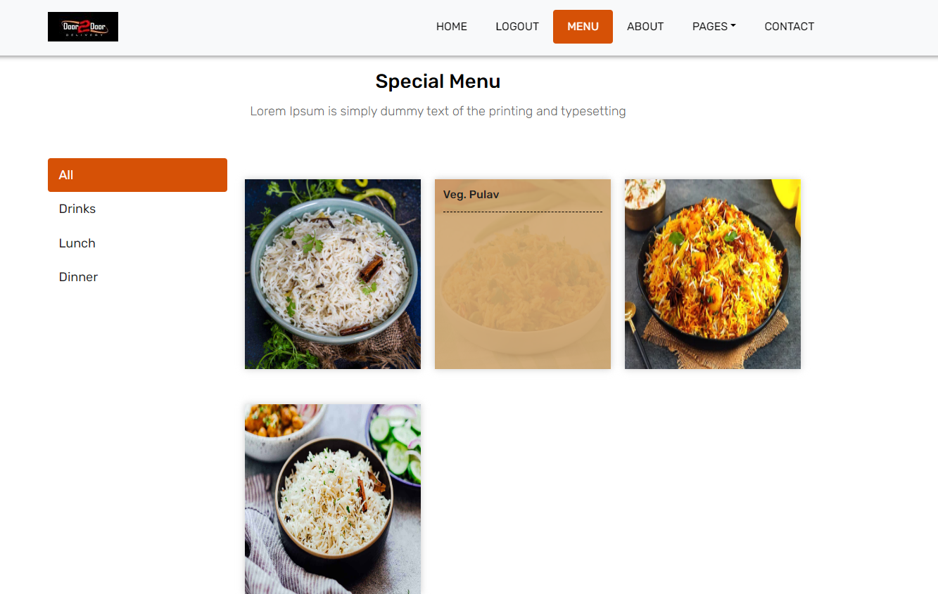

ITEMS DETAIL PAGE:

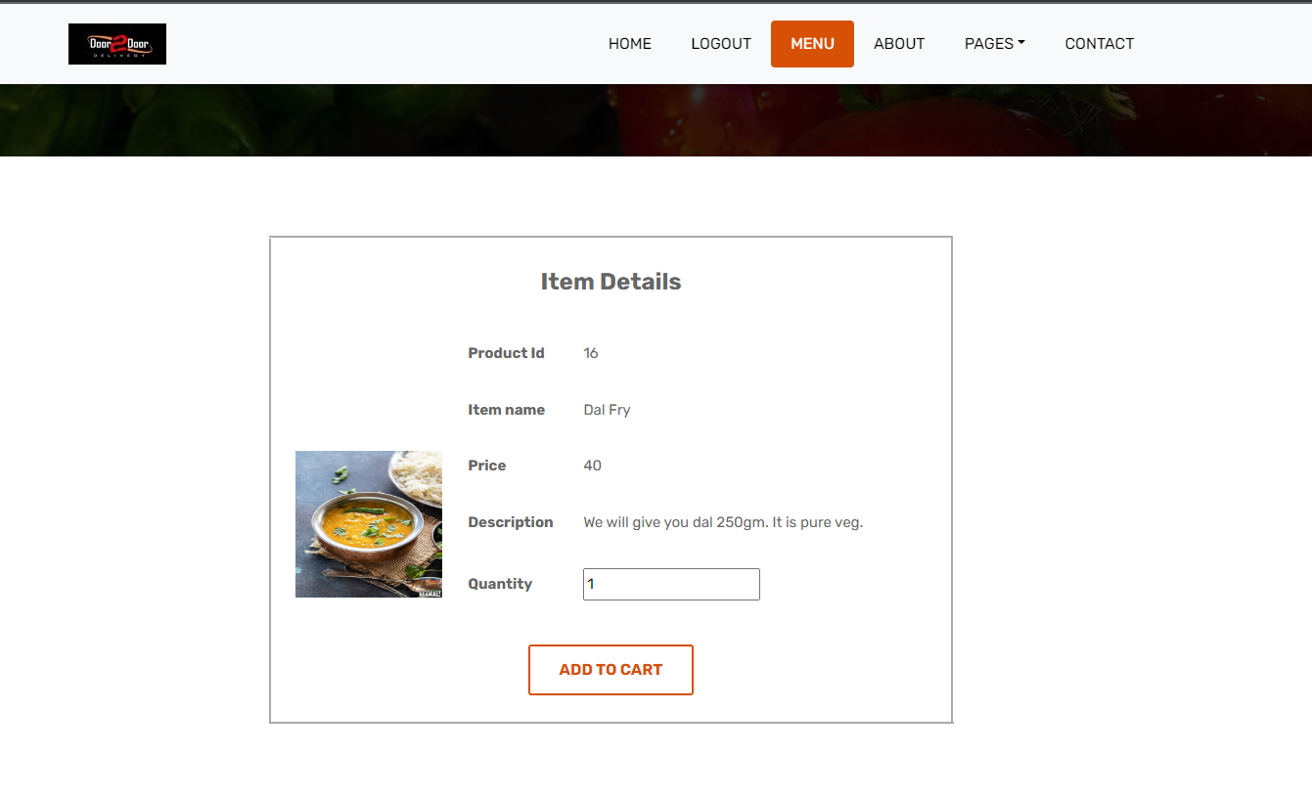

SHOPPING CART PAGE:

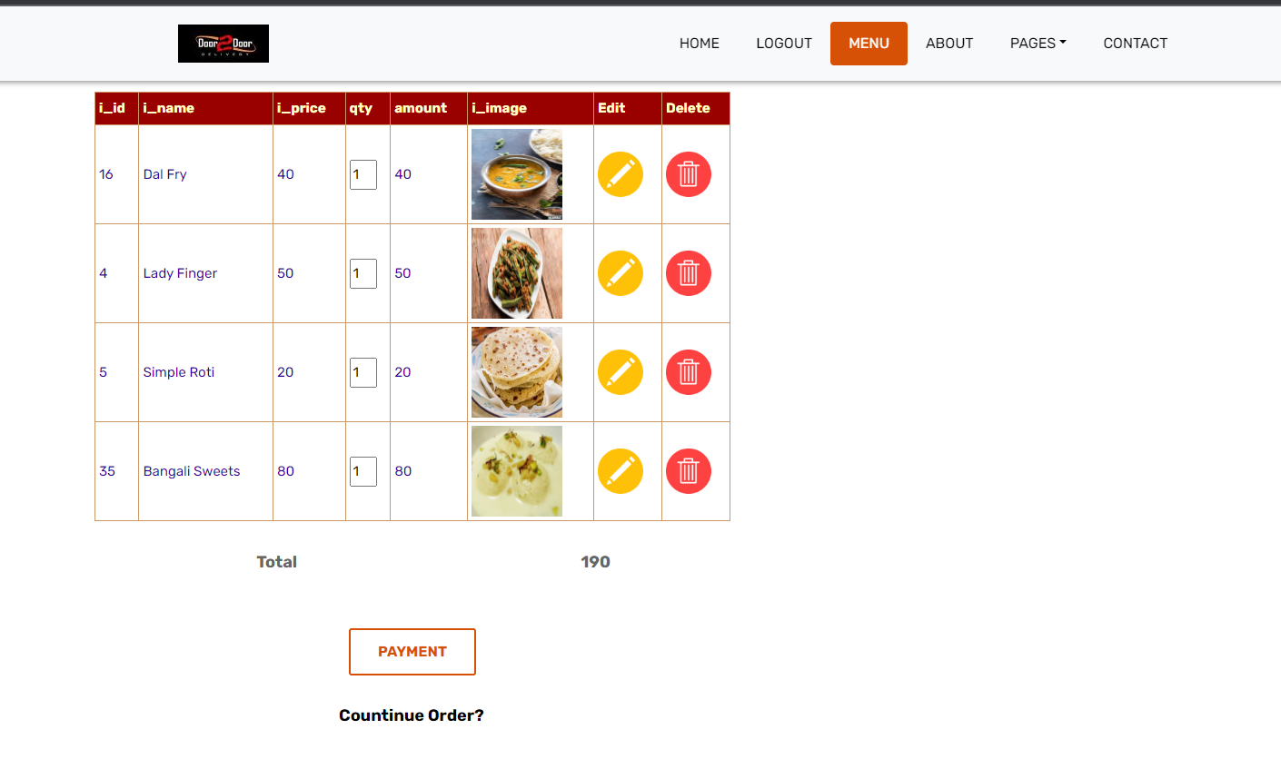.

CHECKOUT PAGE:

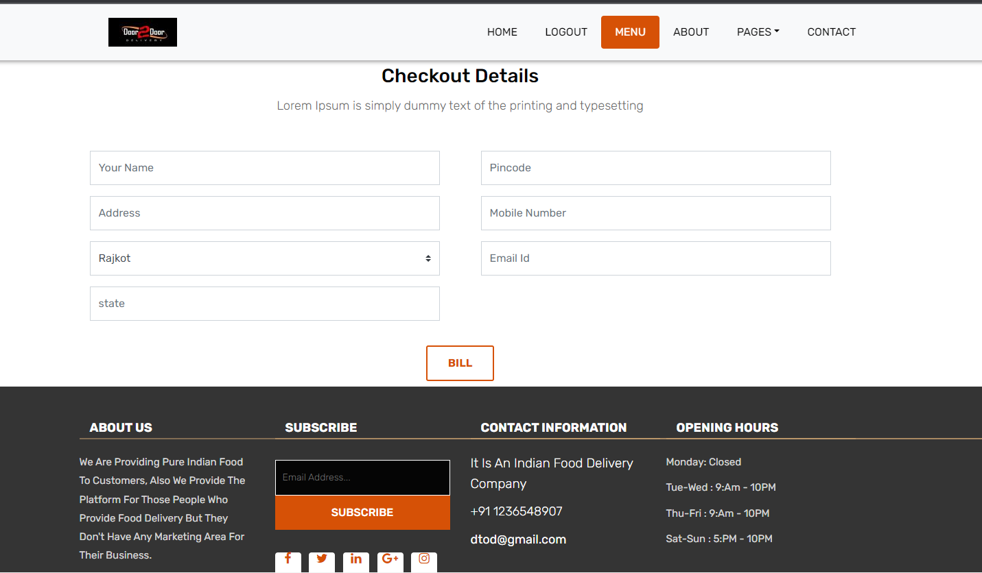

BILLING DETAIL PAGE:

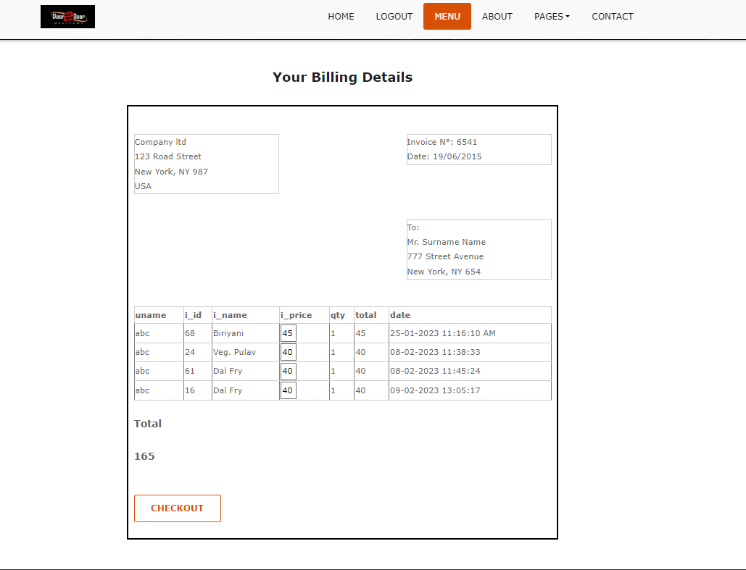

FEEDBACK PAGE:



THANK YOU PAGE:

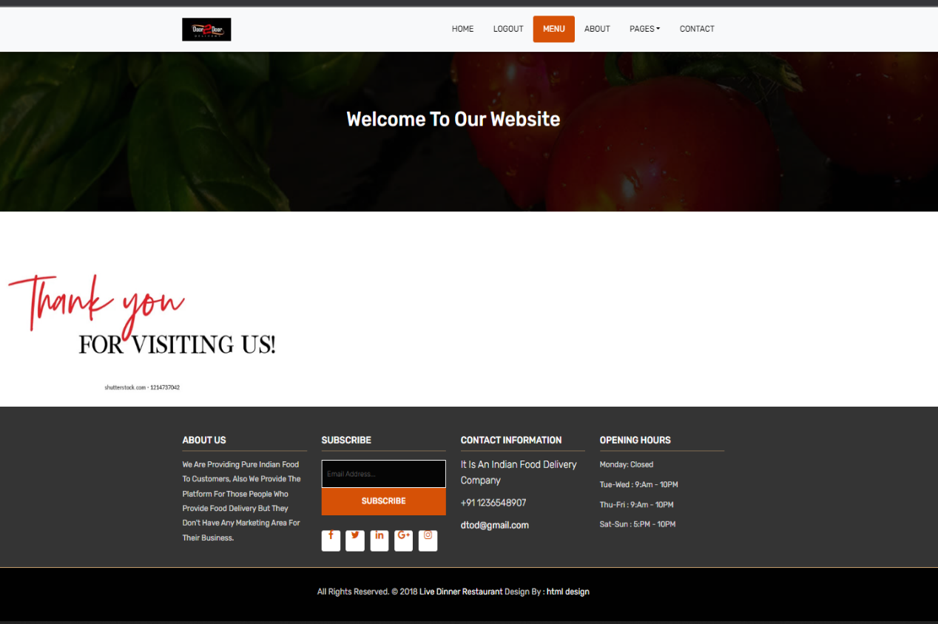

# Test Cases

| **TEST CASE ID** | **TEST SCENARIO** | **TEST STEP** | **TEST DATA** | **EXPECTED RESULT** | **ACTUAL RESULT** |  |
| --- | --- | --- | --- | --- | --- | --- |
| TC : 1 | Check user login with ***valid*** data | 1] :goto localhost :8081 /DoortoDoor/login.aspx  2] : enter user name  3] : enter password  4] : submit | U.N = Khushi  P.W = khushi | User can login and redirect to login.aspx page | As expected | pass |
| TC : 1.1 | Check user login with ***invalid*** data | 1] :goto localhost :8081 /Doortodoor/login.aspx  2] : enter user name  3] : enter password  4] : submit | U.N = abc  P.W = 123 | User can not login this site | As  Expected | pass |
| TC : 2 | Check user side registration with ***valid*** data | 1] goto localhost : 8081/door to door/ registration.aspx  2] Enter First Name  3] Enter Last name  4] Enter Gender  5] Enter Username  6] Enter Password  7] Enter Address  8] Enter phone No.  9] Enter Email  10] Enter city | FN : Khushi  LN :khushi  Gender : female  UN : Khushi  PW : Khushi  ADD : 150 feet  Ring road, Rajkot.  PH.NO. : 99021- 22344  Email : khushi_1 @gmail. Com  City : Rajkot  State : Gujarat | User can register successfully and redirect to  Register form | As Expected | pass |
| TC : 2.1 | Check user side registration with ***invalid*** data | 1] goto localhost : 8081/door to door/ registration.aspx  2] Enter First Name  3] Enter Last name  4] Enter Gender  5] Enter Username  6] Enter Password  7] Enter Address  8] Enter phoneNo.  9] Enter Email  10] Enter city | FN :abc  LN :abc  Gender :abc  UN :abc  PW :abc  ADD :abc  PH.NO. :abc  Email :abc  City :abc  State :abc | User can not register through invalid data | As  Expected | pass |

| **TEST CASE ID** | **TEST SCENARIO** | **TEST STEP** | **TEST DATA** | **EXPECTED RESULT** | **ACTUAL RESULT** |  |
| --- | --- | --- | --- | --- | --- | --- |
| TC : 3 | Check  category details with ***valid*** data | 1] :goto localhost :8081 /door to door/category.aspx  2] : Enter user name  3] : Enter password  4] : Submit | UN=Khushi  PW=khushi | User can watch the proper category page | As  Expected | pass |
| TC : 3.1 | Check category details with ***invalid*** data | 1] :goto localhost :8081 /  door to door/category.aspx  2] : Enter user name  3] : Enter password  4] : Submit | UN=abc  PW=abc | User **can not** watch the proper category page | As  Expected | pass |
| TC : 4 | Check subcategory &item page with **ADD TO CART OPTION**  With ***valid*** data. | 1] :goto localhost :8081 /door to door/subcategory  .aspx  2] : Enter user name  3] : Enter password  4] : Submit | UN=Khushi  PW=Khushi  **Click on: Add to cart.** | Users **can** properly view and add to cart the items. | As Expected | pass |
| TC : 4.1 | Check subcategory &item page with **ADD TO CART OPTION**  With ***invalid*** data. | 1] :goto localhost :8081 /  door to door/subcategory.aspx  2] : Enter user name  3] : Enter password  4] : Submit | UN=abc  PW=abc  **Click on: Add to cart.** | User **cannot** properly view and add to cart the items | As  Expected | pass |
| TC : 5 | Check Checkout detail with ***valid*** data | 1] :goto localhost : 8081 / door to door / checkout.aspx  2] : Enter first name  3] : Enter Last name  4] : Enter Address  5] : Enter City  6] : Enter Phone No.  7] : Enter Email | FN : Khushi  LN :khushi  Gender : female  UN : Khushi  PW : Khushi  Add : 150 feet Ring road, Rajkot.  PH.NO. : 99021 22344  Email khushi_1@gmail.com | User **can** get and view the proper checkout | As  Expected | Pass |

| **TEST CASE ID** | **TEST SCENARIO** | **TEST STEP** | **TEST DATA** | **EXPECTED RESULT** | **ACTUAL RESULT** |  |
| --- | --- | --- | --- | --- | --- | --- |
| TC : 5.1 | Check user checkout with ***invalid*** data | 1] :goto localhost : 8081 / door to door / checkout.aspx  2] : Enter first name  3] : Enter Last name  4] : Enter Address  5] : Enter City  6]: Enter PhoneNo.  7] : Enter Email | FN :abc  LN :abc  Gender :abc  UN :abc  PW :abc  ADD :abc  PH.NO. :abc  Email :abc | User **cannot** register through invalid data | As  Expected | pass |
| TC : 6 | Check Billing details with ***valid*** data | 1] :goto localhost :8081 /door to door/billing.aspx  2] : Enter user name  3] : Enter password  4] : Submit | UN=Khushi  PW=Khushi | User **can** view and check the billing details | As  Expected | pass |
| TC : 6.1 | Check Billing details with ***invalid*** data | 1] :goto localhost :8081 /door to door/billing.aspx  2] : Enter user name  3] : Enter password  4] : Submit | UN=123  PW=123 | User **can**  **not** view and check the billing details | As  Expected | pass |
| TC : 7 | Check feedback page with valid data | 1] :goto localhost :8081 /door to door/feedback.aspx  2] : Enter user name  3] : Enter review | Name=Khushi  Review=  Excellent  good Average Poor | User **can** give the feedback | As  Expected | pass |
| TC : 7.1 | Check feedback page with invalid data | 1] :goto localhost :8081 /door to door/feedback.aspx  2] : Enter user name  3] : Enter review | Name= 123 | User **can**  **not** give the feedback | As  Expected | pass |

# Future Enhancement

* We are committed to make good, hygienic food available to all at an affordable price by sourcing food directly from the farmers thus helping the farmers at the same time.
* In the future we will apply an online payment method in our project.
* Also we apply a search bar and upload photos to scan photos of products.
* In our project we will also apply language so users can set their known language and get results in their known language.
* In our project we will add a share feature therefore users can share any product to others.
* In our project we will also add view feature therefore user can open our  project in mobile view/tablet view or laptop view.
* To deliver a unique experience to our customers through delivering great food, friendly, attentive service, excellent price and a welcoming presence.

**Advantages**

* We provide hygienic and healthy food.
* Our Tiffin rates are minimum compared to market price.
* We provide the best food quality.
* We provide variety in the menu of full thali and half thali.

**Limitations**

* Users cannot select multiple items at one selection.
* We provide limited items to users for selections.
* We don’t accept online payment.

**References & Bibliography**

* The idea of the project came from **Gaurav Sir**; he inspired us to create a website for home Tiffin service that would provide good and healthy food.
* Through this website we can provide the best Tiffin to people.
* We have also taken some references from **Mumbai’s Dabbawala.**